About the challenge (a little guide for the story)

* Definition of space weather
* A few examples of how space weather impacts Earth
* A clearly defined character whose point of view will be used to tell the story. For instance:
  + What is the person’s name?
  + How old are they?
  + What do they do?
  + How are they connected to space weather?
  + What challenges do they face?
* Explanation of how space weather directly and indirectly impacts the person’s life and work.
* Think about how you could depict the impact of space weather on the lives of those on Earth.

(choose a couple of people who are affected by space weather like: astronauts, pilots, taxi/ride share drivers, farmers, park rangers, teachers, chefs, fishers, scientists, engineers, video game producers, lifeguards, photographers, artists, accountants, informational technology (IT) workers, electricians or anyone also talk about how beautiful auroras are but beauty is not everything aka they are harmful) also *refer to the Resources tab at the top of the page.*.

Fun fact to add : Although space weather existed for millions of years we are affected more by it currently than before due to our heavy independence on technology. Even after a lot of research, what makes space weather particularly interesting is the fact that we are still learning which end-user communities are impacted by the phenomena and in what ways (lol we actually know very little about our universe).

THIS IS IMPORTANT SO READ IT ⬆⬆

Ps. i will attach resources beside everything in little ()

Main information

Magnetic field: it is an invisible force that pulls planets and sun together along with gravitational force (ps. Idk if you should add it or not but im pretty sure a 10 yo doesn't know what a magnetic field). The Earth, Sun and other planets and stars have magnetic fields due to having a super hot metal like inner core that swirl around itself that produces electricity resulting into having invisible magnetic waves around the earth and protects the earth from radiations of the sun, while the magnetic field of the sun is due to its gaseous plasma making the magnetic waves unstable and harsher than earth’s.

What is space weather? conditions in the region of space close to the earth, especially the presence of [electromagnetic](https://www.google.com/search?sca_esv=fc1f47d9dc5800d6&sxsrf=AE3TifNvKO3pSQkAPoI9pIhc-ktouNzCrA:1758110474095&q=electromagnetic&si=AMgyJEtWkSEV2aLNX-MYa8jWmM855QMRjMHCB4McYR5FHy3TnpDsydJYC-sYI2OiW2NRbEElV2CA2cn_w8omiMV3-aRkEAl3PEgfvKitItDWSX1-_drkz10%3D&expnd=1&sa=X&ved=2ahUKEwiJ0KLy39-PAxUkK_sDHX1RBC8QyecJegQIFhAR) radiation and charged particles [emitted](https://www.google.com/search?sca_esv=fc1f47d9dc5800d6&sxsrf=AE3TifNvKO3pSQkAPoI9pIhc-ktouNzCrA:1758110474095&q=emitted&si=AMgyJEtpyiSdZyr-ht-KvQyAhGlD4tn0EgXvskIz3TFBwtlCptDLnp6RsER8jEszWtdYItxdRVL76_wBGrd1jPOVu-dZuNhHag%3D%3D&expnd=1&sa=X&ved=2ahUKEwiJ0KLy39-PAxUkK_sDHX1RBC8QyecJegQIFhAS) by the sun, that can affect human activity and technology such as Solar flares, coronal mass ejections, solar particle events, and the solar wind. (oxford language and NASA space weather website)

What is CME? CME or Coronal mass ejection are large expulsions of plasma and magnetic field from the Sun’s corona (the sun's atmosphere which reaches a temperature of 2 or 3 million fahrenheit). (Space Weather Prediction Center NOAA) MORE ABOUT CME ➡ Sometimes when magnetic energy is released the corona becomes so disturbed that large pieces of it are released into space. Billions of tons of solar material and magnetic field are hurled from the Sun into interplanetary space at speeds up to several million mph. As they move away from the Sun they expand becoming as wide across as the distance from the Earth to the Sun. CMEs can occur when filaments/prominences become unstable and fly away from the Sun. We call this a filament/prominence eruption. (the sun today website)

Heliophysics: Heliophysics research data seeks to understand the nature and dynamic interactions of the Sun, the heliosphere, and the plasma environments of the planets and interstellar space. (NASA space weather website)

What is Solar Flare? Solar flares are a sudden, explosive release of magnetic energy in the form of electromagnetic radiation (most of the light spectrum, from radio waves to gamma-rays) and very fast atomic particles. Solar flares occur in regions of concentrated magnetic fields such as sunspots. (the sun today website) (Flares happen when the powerful magnetic fields in and around the sun reconnect, causing an explosion) Although X is the last letter, there are flares more than 10 times the power of an X1, so X-class flares can go higher than 9. The most powerful flare on record was in 2003, during the last solar maximum. It was so powerful that it overloaded the sensors measuring it. They cut-out at X28. A powerful X-class flare like that can create long lasting radiation storms, which can harm satellites and even give airline passengers, flying near the poles, small radiation doses. X flares also have the potential to create global transmission problems and world-wide blackouts.

What are solar energetic particles? The Sun goes through phases of strong activity, during which eruptions can occur. Such eruptions can have multiple components, bursts or events of fast-moving particles. These events can occur suddenly and have the potential to rapidly change the radiation environment of wide swaths of the inner solar system where they may create hazardous conditions.

What is Solar Wind? The outer corona is heated up to such high energies that it eventually expands away from the Sun as a stream of electrons, protons and other atomic particles. The stream travels away from the Sun at speeds of around 200-400 km/s but can reach speeds of 900 km/s. The solar wind fills the entire solar system so all the planets sit inside the outer solar atmosphere. We live inside the atmosphere of a star. Sometimes concentrated high-speed solar wind streams come from the Sun and impact the Earth. These can produce magnetic disturbances in the Earth's upper atmosphere called a geomagnetic storm and produce the Southern and Northern Lights (The Aurora).

What is Solar storm? A solar storm is a sudden explosion of particles, energy, magnetic fields, and material blasted into the solar system by the Sun due to the sun creating a tangled mess of magnetic field with its equator rotating faster than its poles.

What happens when CME or flare contact with Earth’s magnetic environment? induce electrical currents that flow through power grids leading to power outages. temporarily heat up Earth’s upper atmosphere, causing it to swell and increase drag on some Earth-orbiting satellites, which makes the satellites slow down and lose altitude. bombard Earth with charged particles that interact with atoms and molecules in Earth’s atmosphere to create the aurora borealis and australis (northern and southern lights).

Do all flares and CMEs affect the earth? Not all flares or CMEs affect the earth since some are very weak and some don't even fully reach the earth’s magnetic field.

Solar activity cycle: the sun has a cycle of around 11 years where its very active so CME, Flares and storms occur occasionally during the maximus but less likely to happen during the low point of the cycle. Sunspots, or dark “blemishes” on the Sun, also increase during solar maximum and mark magnetically active regions on the Sun, which give rise to solar eruptions.

Why are there more flares and CMEs happening now? As previously explained in the solar activity, we are currently in the active cycle of the sun therefore we face more flares and CMEs.

HOW DOES SPACE WEATHER AFFECT US?

## **Navigation Systems** Disturbances in the ionosphere can cause degradation in GPS range measurements and in severe circumstances, loss of lock by the receiver on the GPS signal.

## **Electric Power** Large currents in the ionosphere can induce currents in power lines. Surges from these induced currents can cause massive network failures and permanent damage to electric grid components.

## **Aviation** Space weather storms can cause lost or degraded communications, radiation hazards to crew and passengers, unreliable navigational information, and problems with flight-critical electronic systems.

## **Human Space Exploration** Energetic particles present a health hazard to astronauts on space missions as well as threats to electronic systems. During space missions, astronauts outside spacecraft are less protected and more exposed to space radiation.

## **Satellite Operations** Highly energetic ions penetrate electronic components, causing bit-flips in a chain of electronic signals that can result in improper commands within the spacecraft or incorrect data from an instrument. Less energetic particles contribute to a variety of spacecraft surface charging problems, especially during periods of high geomagnetic activity.

## **Communications** communications at all frequencies may be affected by space weather. High frequency (HF) radio communications are more routinely affected because this frequency band depends on reflection by the ionosphere to carry signals great distances

**Health** It is commonly agreed that solar activity has adverse effects first of all on enfeebled and ill organisms. Where it can affect human health, possibly by disrupting the circadian rhythm and downstream physiological functions. Severe disruption of the circadian rhythm increases inflammation which can induce fatigue, fever and flu-like symptoms in a fraction of the population and worsen existing symptoms in old and diseased individuals, leading to periodic spikes of infectious and chronic diseases.

EXAMPLES OF SOME MAJOR SPACE WEATHER EVENTS

#### **September 1859**

Aurora bright enough to read by, seen extremely far south (Cuba). Telegraph systems ran without being powered. Some caught on far and operators were electrocuted. Considered to be the largest solar storm on record (estimates for an event of this magnitude today are up to $2 trillion).

#### **May 1921**

The entire New York Central Rail switching system was knocked out. Telegraph and telephone disruptions worldwide.

#### **March 1989**

A huge magnetic storm caused the Quebec power grid to fail in 90 seconds leaving millions without power for up to 9 hours (total cost not just to the Quebec power grid estimated at over $2 billion).

#### **October/November 2003**

Major loss of GPS accuracy with errors over 50 meters, transformer failures in South Africa, major HF radio blackouts, 30 satellite anomalies including one satellite loss (many billions of $s).

## Aurora its Natural phenomena that is Multicolored Lights (usually a milky greenish color, auroras can also show red, blue, violet, pink, and white) that is caused by collision between fast-moving electrons from space and gases (oxygen and nitrogen) resulting in making the electrons excited therefore they release (photons) small bursts of energy the form lights, and it can primarily be seen at high latitudes usually near the North and South Poles.

Auroras are a spectacular sign that our planet is electrically connected to the Sun where these light shows are provoked by the energy that's electrically fueled coming from the sun hitting the earth's magnetic field. While it's beautiful to look at, it actually harms the magnetic field which will cause various disturbances in modern technology.

FUN FACTS TO ADD

* Just this month, CACTus (software package to detect CME in image sequences from LASCO telescope) detected by **SECCHI-A** satellite ones of the highest velocity CME on13th of September at 11:53, maxV is equal to 1785 and minV is equal to 0694 both measured in km/s. (Solar Data Analysis Center)
* Although our Sun is the biggest object in our solar system and is the closest star to earth (only 93 million miles away from our dear planet) The sun is an average star, its size, age, and temperature fall in about the middle of the ranges of these properties for all stars.
* On July 23, 2012, a massive cloud of solar material erupted off the sun’s right side, zooming out into space. It soon passed one of NASA’s Solar Terrestrial Relations Observatory, or STEREO, spacecraft, which clocked the CME as traveling between 1,800 and 2,200 miles per second as it left the sun. This was the fastest CME ever observed by STEREO. (the sun today website)
* The energy from a flare travels at the speed of light, which means it reaches Earth about 8 minutes after a flare happens. Essentially, by the time we see a flare, most of its effects are here. (Solar storm and flare)
* High speed particles from the solar eruption get past most of Earth’s magnetic defenses, following Earth’s magnetic field lines toward the north and south poles, where they enter our atmosphere and possibly even hit the ground (but don’t harm anyone on the ground) and they knock electrons off of atoms and molecules in our atmosphere (ionizing them), altering high-frequency radio communication.
* CME can move in different directions at various speeds; the fastest ones travel at millions of miles per hour.
* This year the sun emitted a strong flare on 17th of June, exactly at 5:49 p.m. ET, this flare is classified as an X1.2 flare. X-class denotes the most intense flares, while the number provides more information about its strength. This picture was captured during the flare by NASA’s Solar Dynamics Observatory, the image shows a subset of extreme ultraviolet light that highlights the extremely hot material in flares and which is colorized in teal.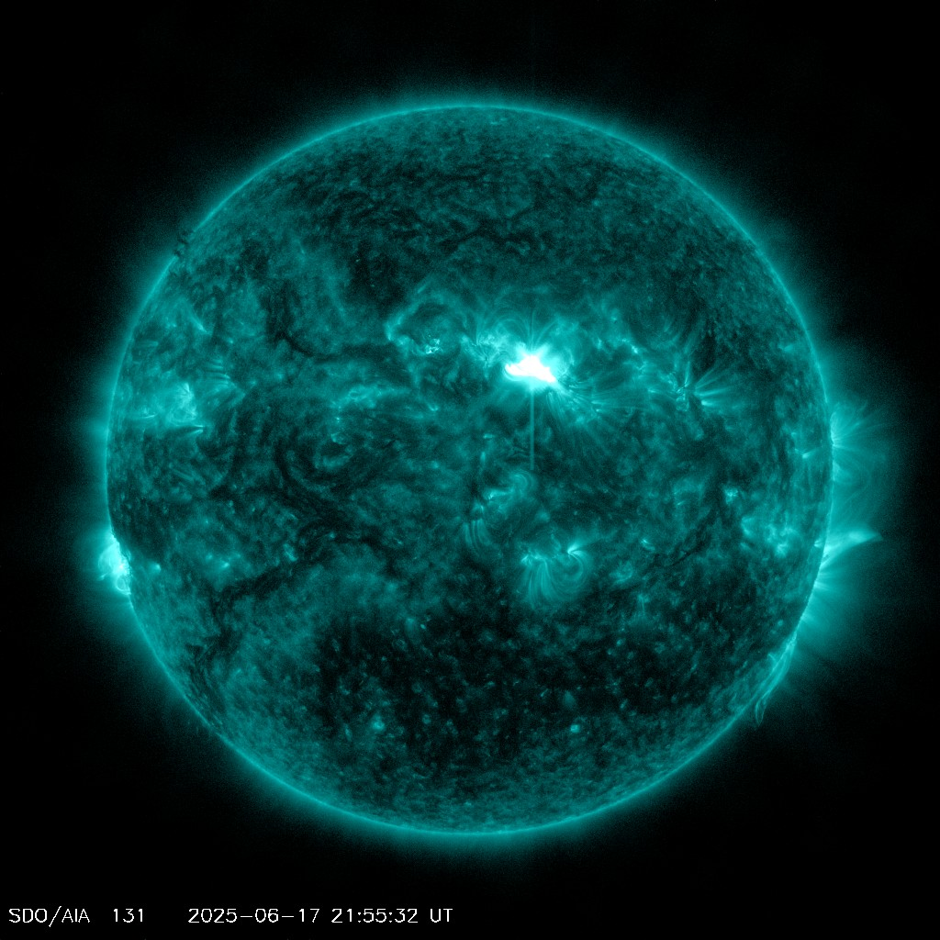
* Aurora was actually named after the Roman goddess of dawn.
* The color of the aurora depends on which gas is being excited by the electrons and on how much energy is being exchanged. Oxygen emits either a greenish-yellow light (the most familiar color of the aurora) or a red light; nitrogen generally gives off a blue light. The oxygen and nitrogen molecules also emit ultraviolet light, which can only be detected by special cameras on satellites.

IMAGES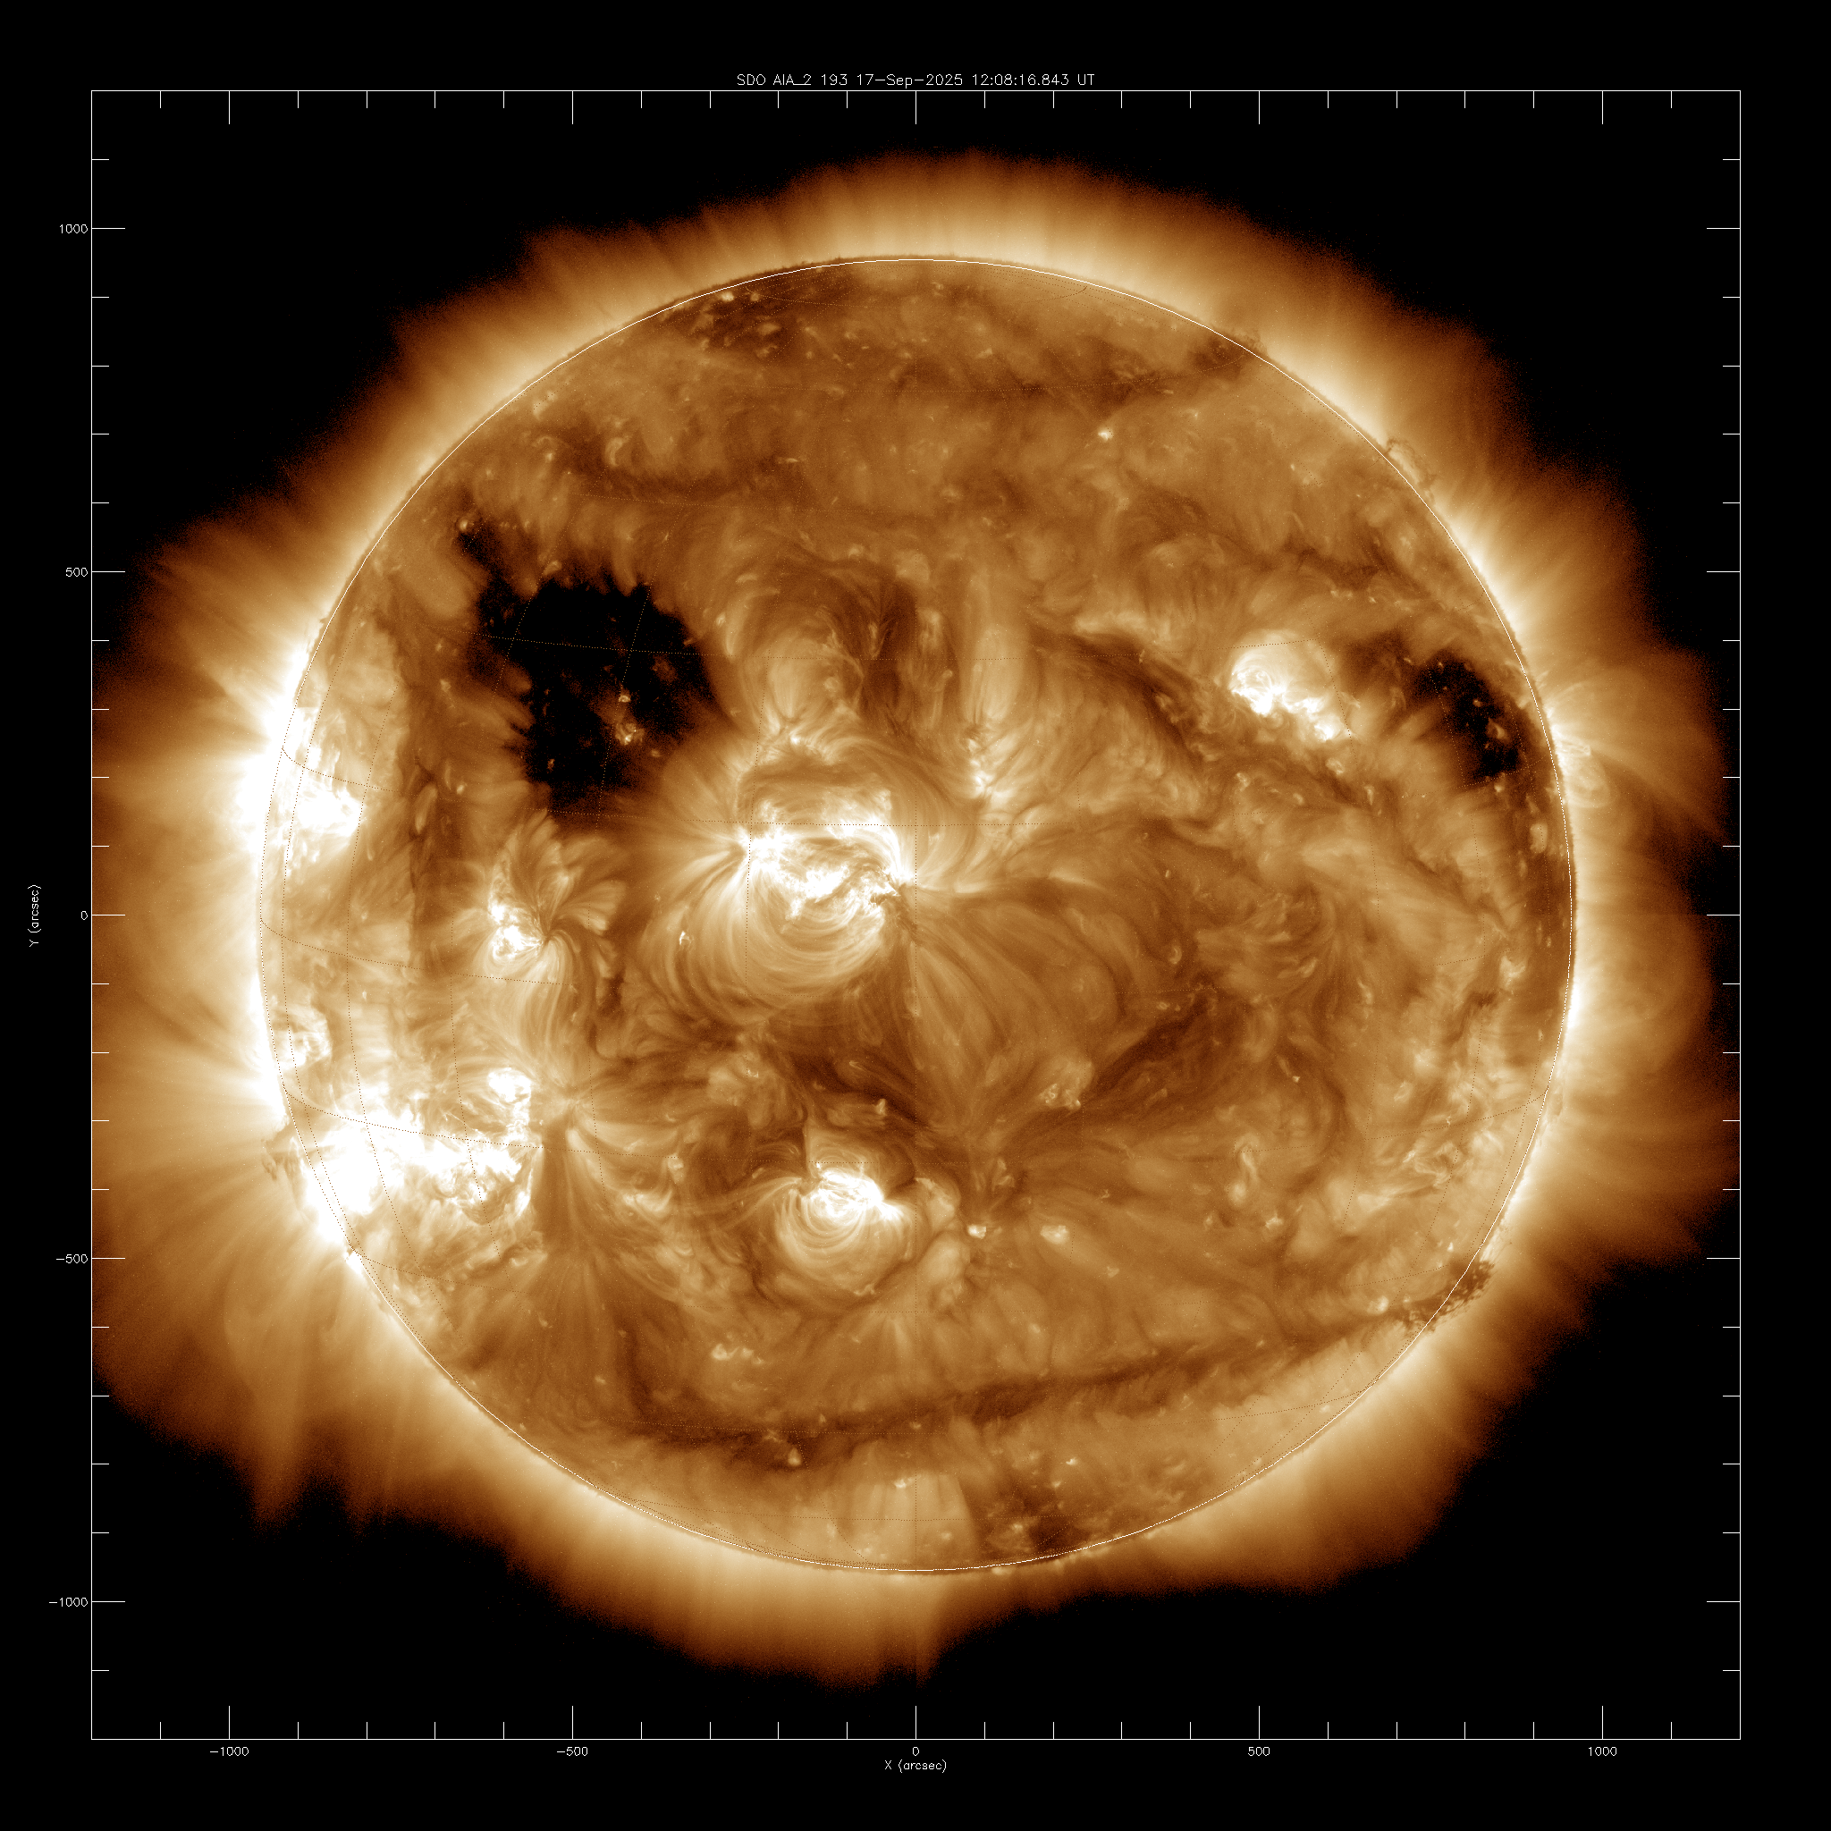

South East Limb AR Complex a few low to mid C flares, at least one explosive eruption(solarmonitor.org)

6.5 Hours with Canonical CME EUV Signatures EUV shock/blowback  
beautiful post eruption arcade - projection angle/foreshortening + imagination..  
sequential brightening of arcade loops may trace a sigmoidal filament channel  
Will see if that sigmoidal morphology is confirmed *tomorrow*as the region rotates to less inclined vantage points…

من الاخر يعني ده الجزء الجنوب الشرقي من الشمس وهو بيطلع الإشعاعات بس لحسن الحظ ده بيطلع إشعاعات ضعيفة اللي هي (mid c-flare)

C-class flare the weakest radiation and the most emitted.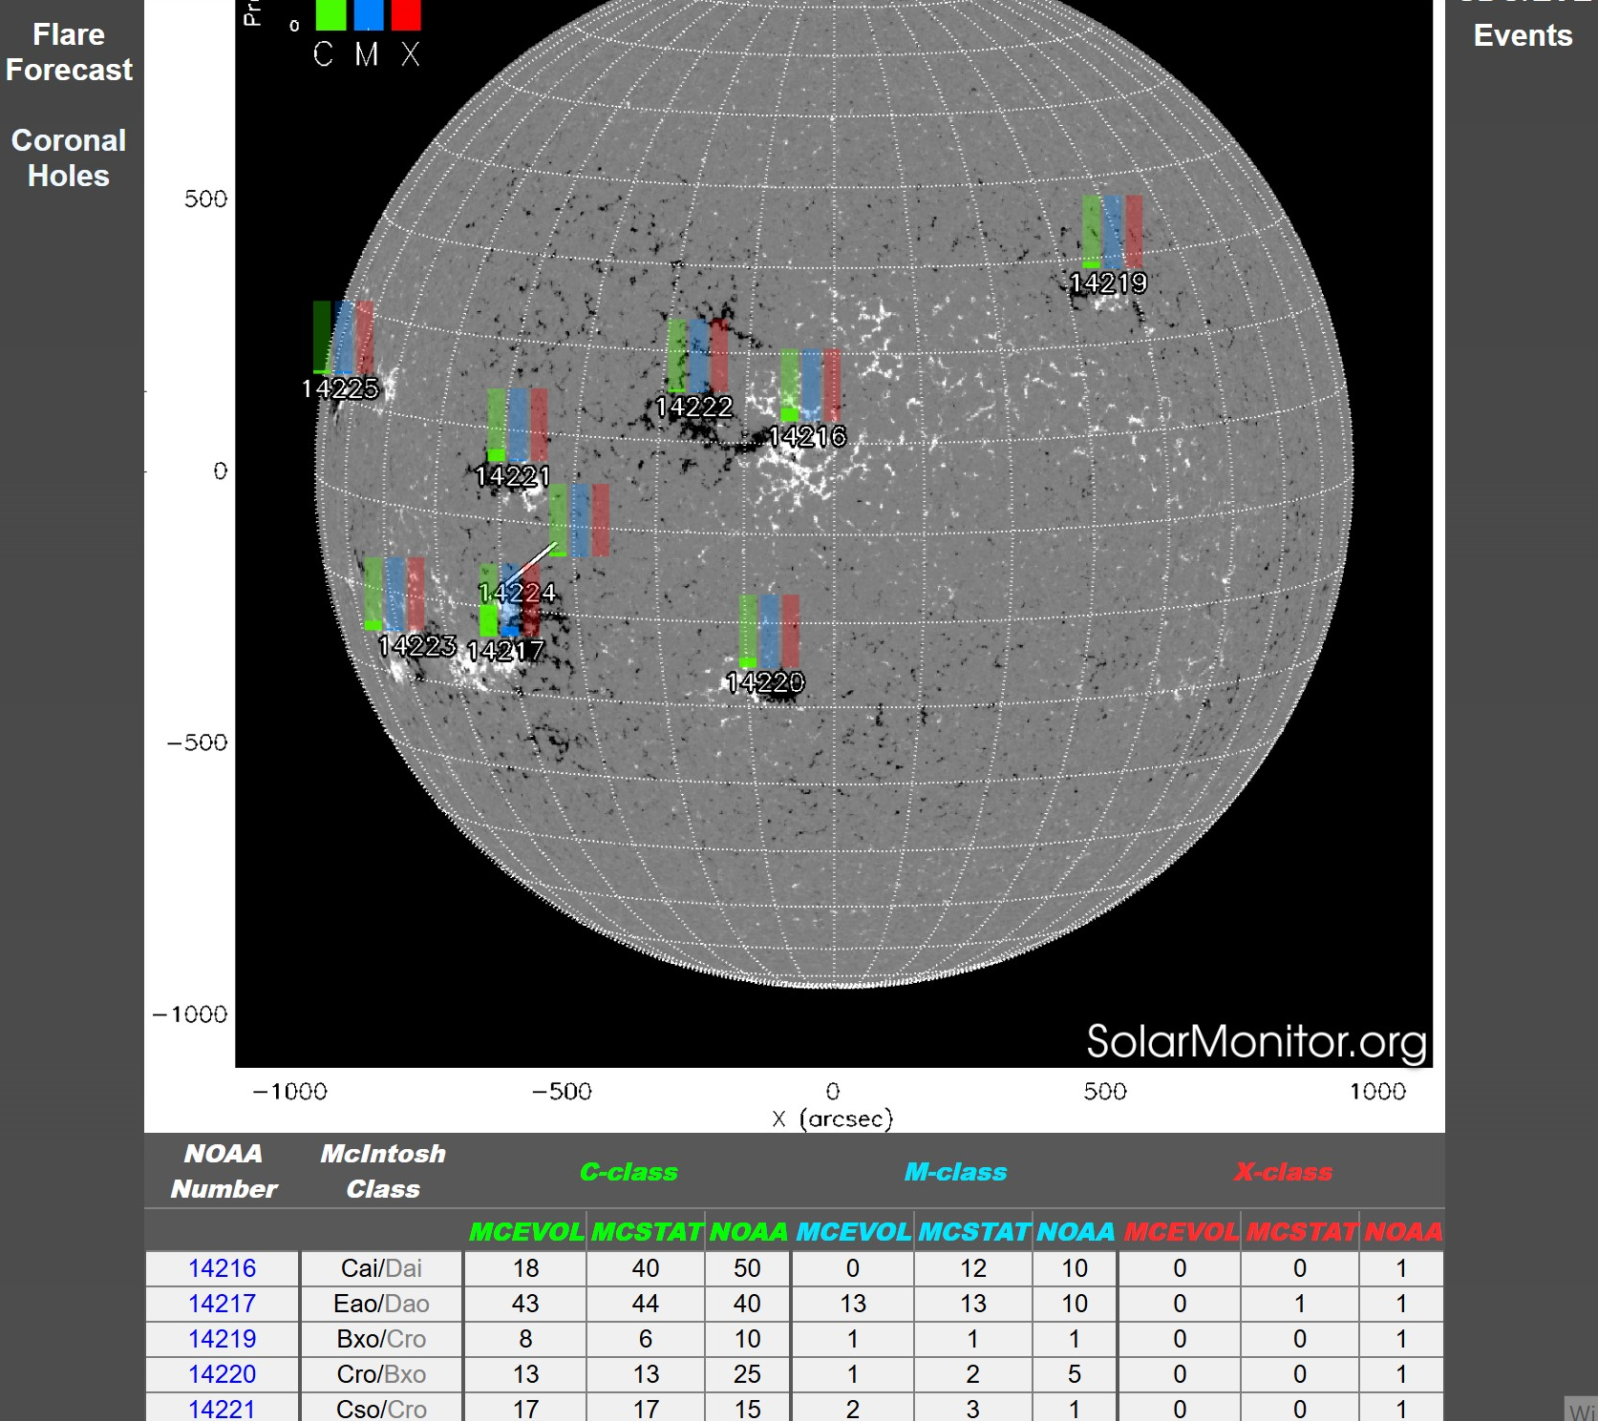

M-class flare mid radiation mid emission

X-class flare strongest radiation lowest emission

### Flare classes A through M are divided further using numbers 1 through 9, with 9 being the strongest.

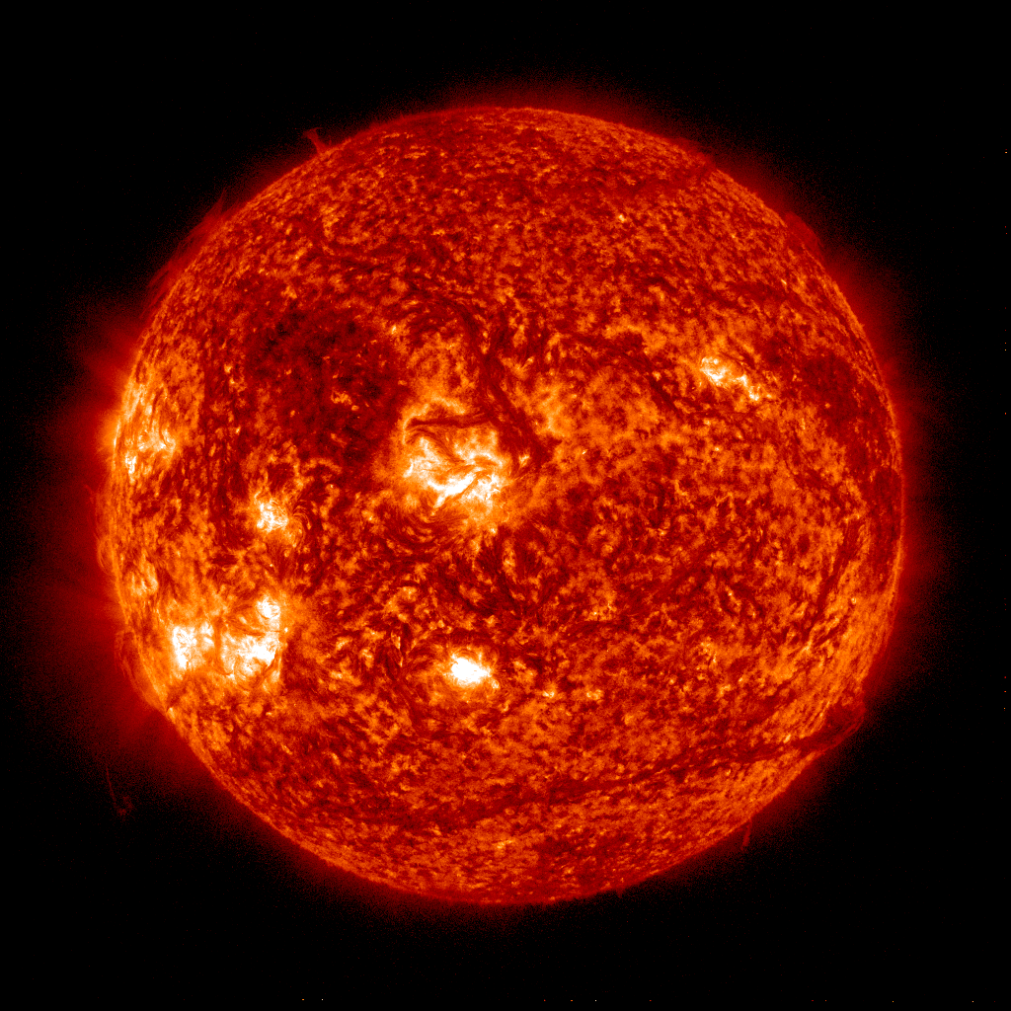

He II 304 Å (Angstrom) is an ultraviolet spectral line from ionized helium (He II) with a wavelength of 304 Angstroms (30.4 nanometers) that is used to observe the Sun's chromosphere and transition region. (SOHO images)

He II 304 Å (Angstrom) is an ultraviolet spectral line from ionized helium (He II) with a wavelength of 304 Angstroms (30.4 nanometers) that is used to observe the Sun's chromosphere and transition region. (SOHO images)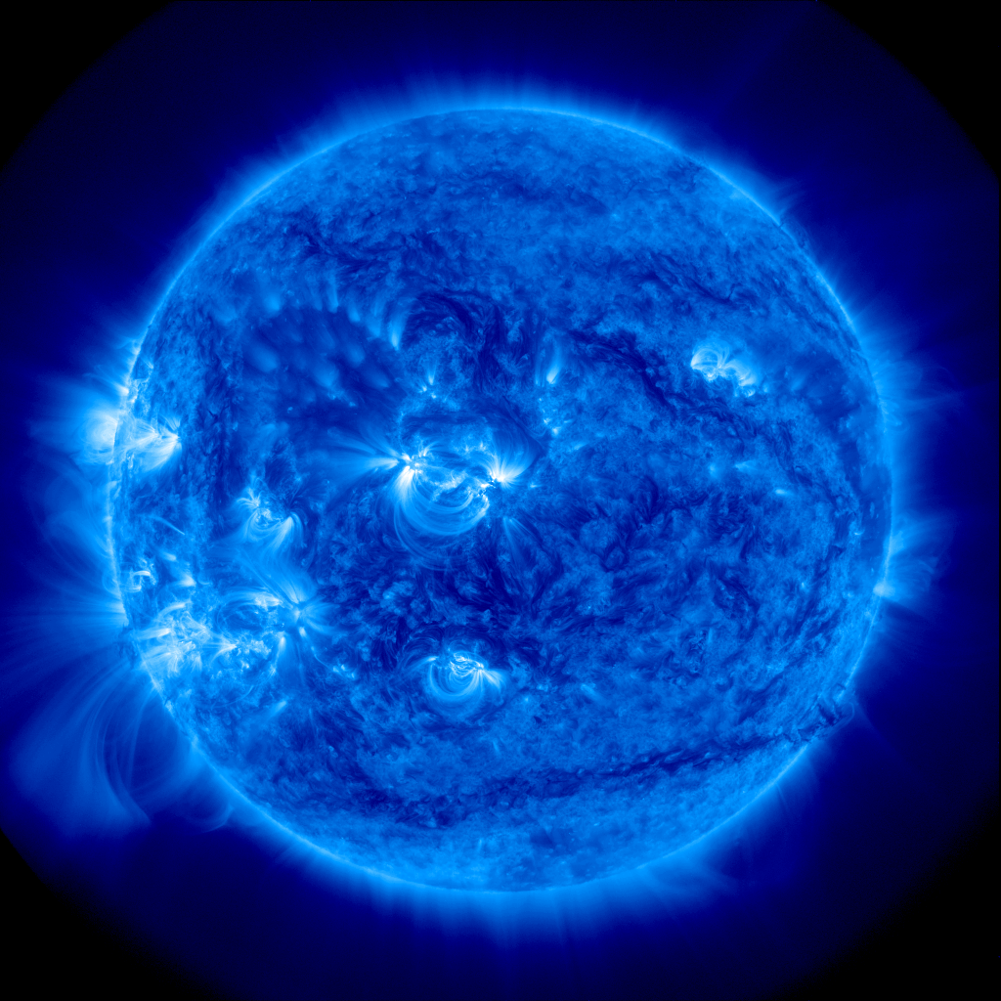

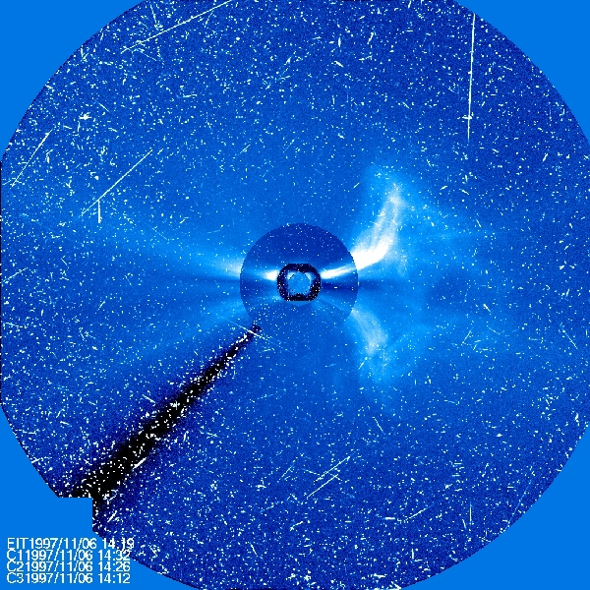

When a large solar flare or CME occurs they can accelerate a large number of atomic particles, electrons, protons and various elements to very high energies. When SEPs impact the cameras on a spacecraft the recorded images look like a television screen with a lot of static or snow.

Solar wind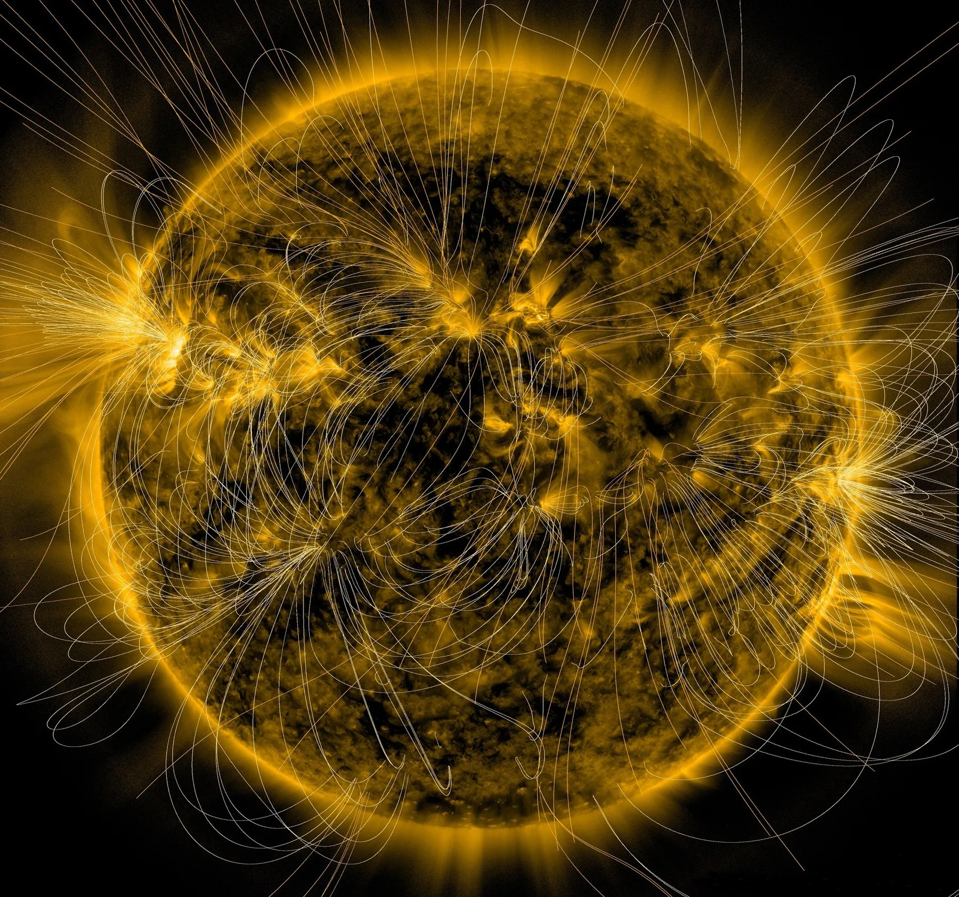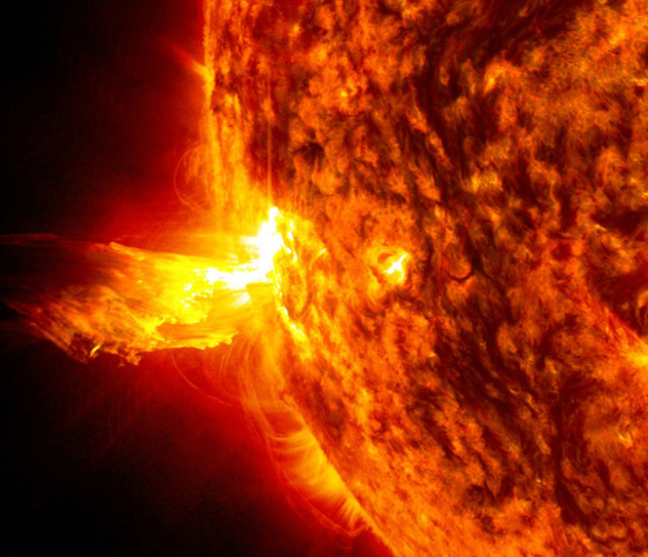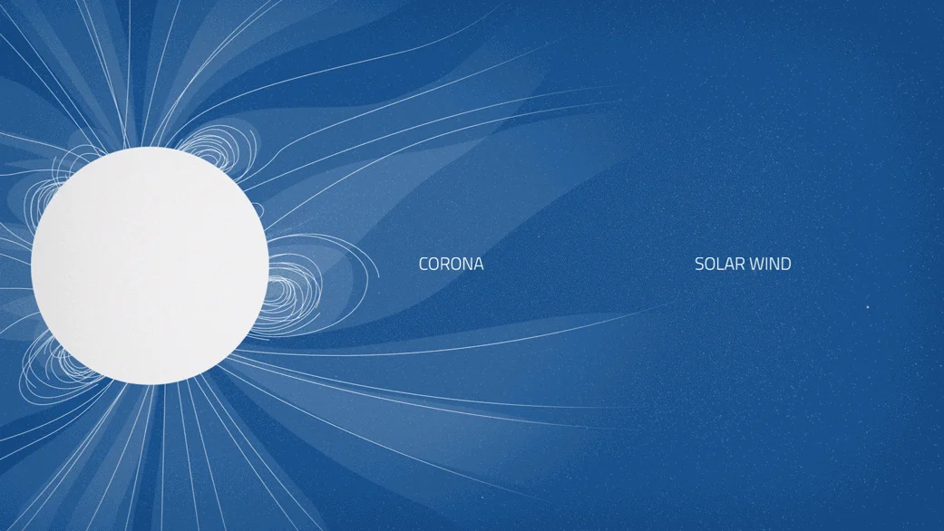

Solar storm